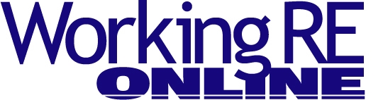
Ask These Questions When You Interview a Call Center
By Paul Zak, President of Inspector Office Solutions - America's Call Center
As a home inspector, you inspect to certain standards when you perform a home inspection, right? Most credible inspectors do, especially those who are members of one of the professional home inspector associations. This way, your clients and agents know the scope of the inspection; it will always be the same scope because those are the standards professional home inspectors follow.
But when it comes to selecting many other services, there are no standards. One example is call centers that serve inspectors. Here is a list of important questions to ask when hiring a call center.
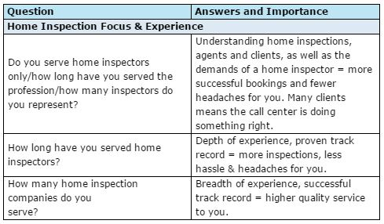
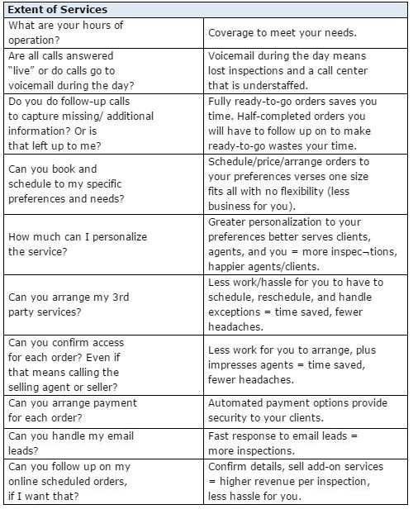
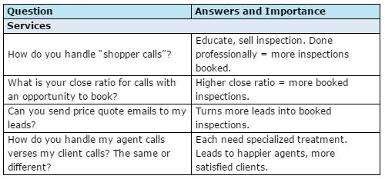
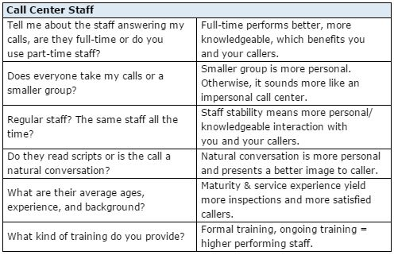
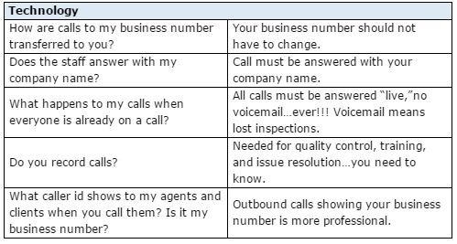
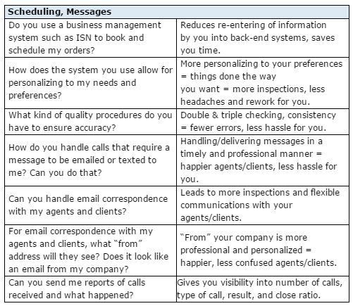
Regardless of the level of support you are looking for from a call center, be sure to feel comfortable with them (heck, if you are not comfortable talking to them, what about your agents and clients!). Feel you can trust them and ask for references so you can speak to other inspectors using their services for a good peer-to-peer discussion.
Not all home inspectors are the same, right? Skill level, services, price. Same for call centers. Prepare yourself by knowing what level of service and support you need from a call center, have your questions ready and you’ll be much more prepared to make a good decision on whom to use. And with that good decision should come more inspections and less stress for you!
Free Liability/Insurance Webinar
>Claims and Complaints: How to Stay Out of Trouble
Available Now
Presenter: David Brauner, Senior Insurance Broker OREP
David Brauner, Senior Broker at OREP, shares insights and advice gained over 20+ years of providing E&O insurance for inspectors, showing you how to protect yourself and your business. Watch Now!
(Get a quick E&O/GL quote from OREP in 30 seconds. Premiums begin around $1,000.)
About the Author
Paul Zak is President of America’s Call Center – Inspector Office Solutions. He has helped hundreds of home inspection companies prosper by providing phone answering and scheduling solutions, significantly boosting the revenue, customer service, and professional image of the inspector. America’s Call Center is a leader in the industry and provides solutions customized to fit your needs. The result is more inspections for you, more revenue per inspection from ancillary services, and an enhanced professional image.
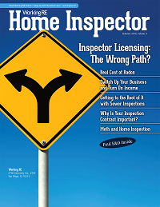

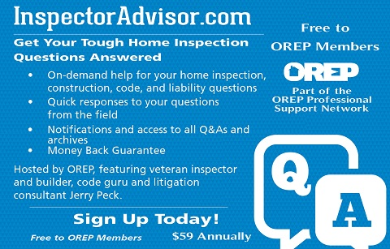
http://www.inspectoradvisor.com
http://www.inspectionsupport.net/trial/
http://www.homeinspectorpro.com/

